Workshop 2

Home-Login-Registration-Profile

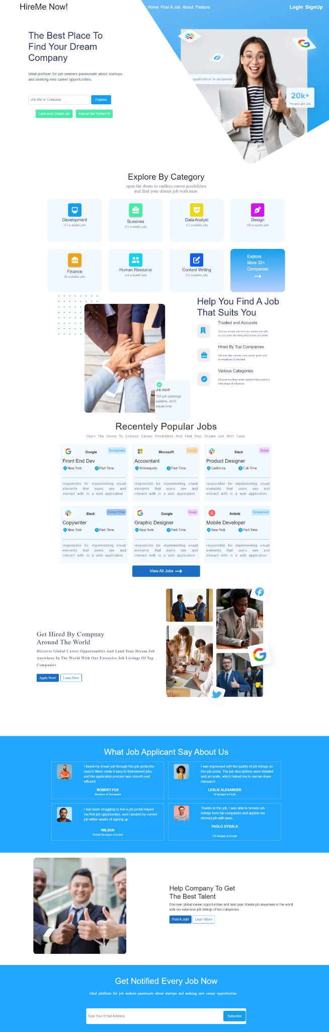

### **Login Screen :**

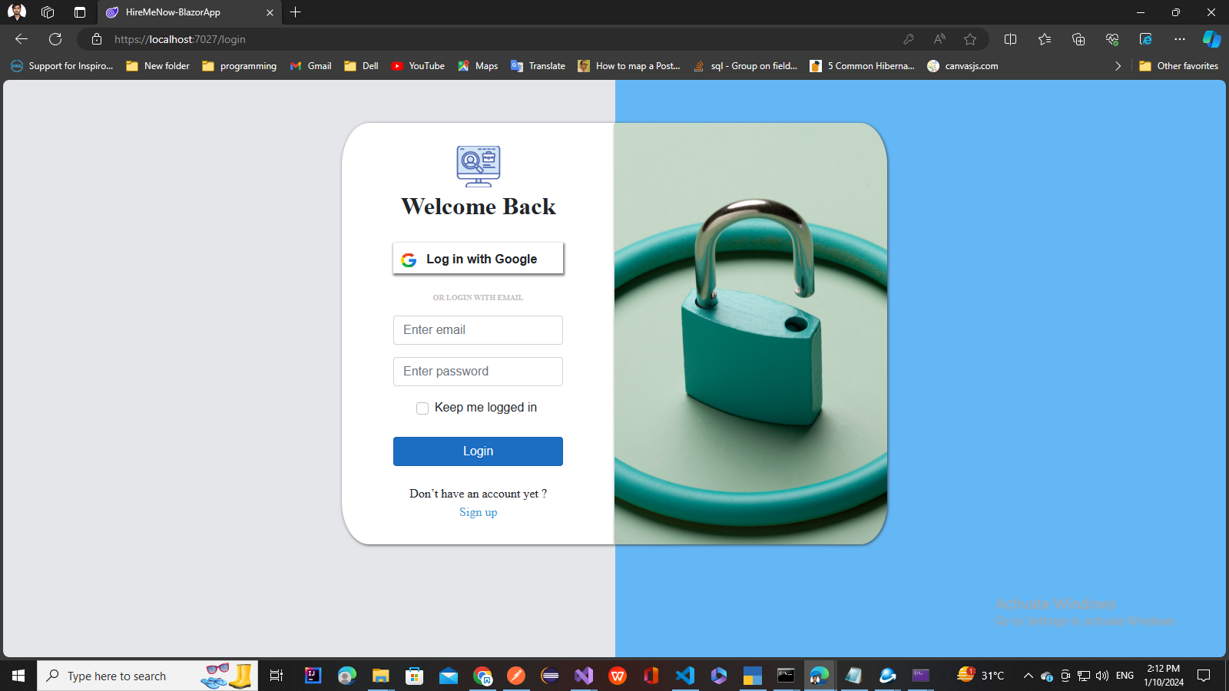

### **Registration Screen :**

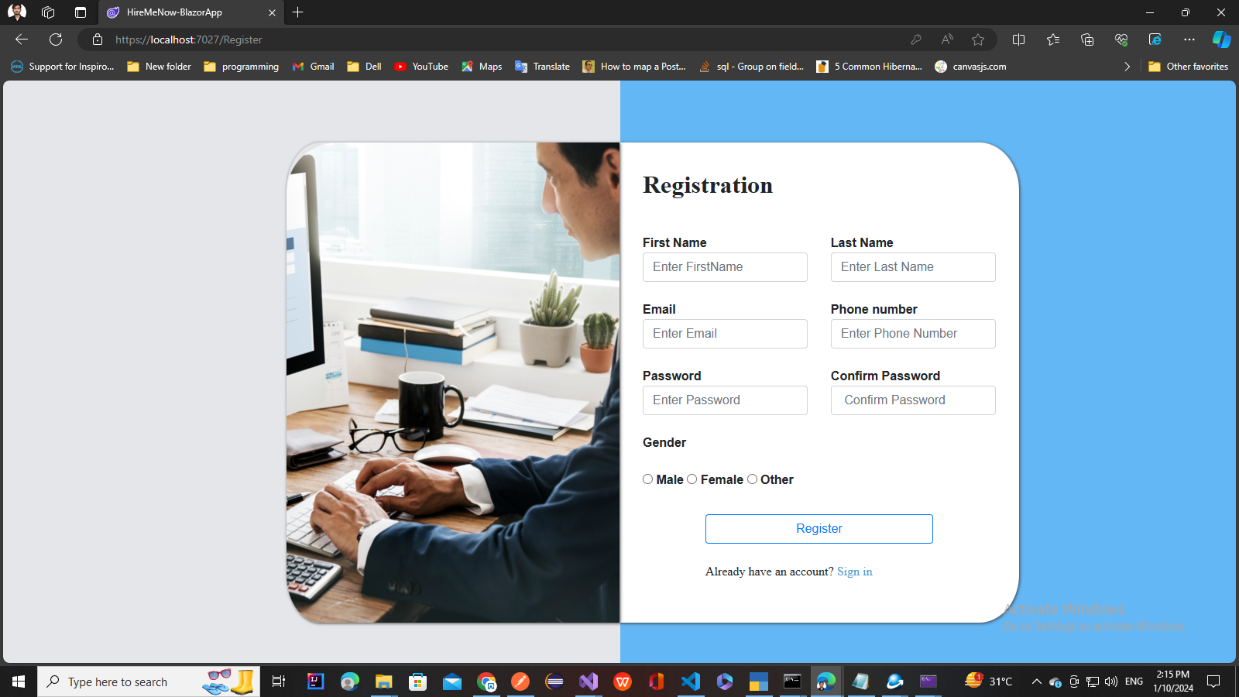

**Profile Page**

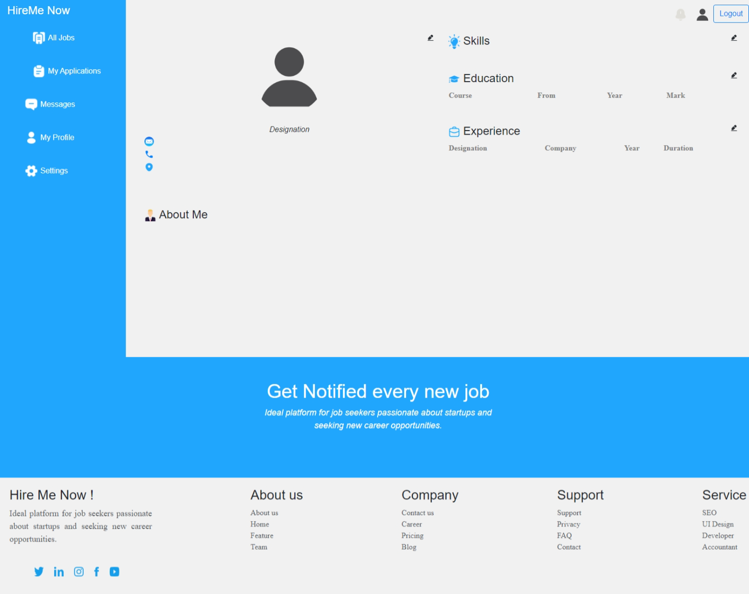

### **Overview:**

Blazor is a framework for building interactive web applications using C# and .NET. In this workshop, we'll explore the fundamentals of Blazor by creating pages for a job portal application.

### **Workshop Goals:**

* Understand the basics of Blazor and its components
* Create a job list page using Blazor components
* Implement functionality for login , register, Profile

### **Prerequisites:**

* Basic knowledge of C# and .NET Core
* Familiarity with HTML, CSS, Bootstrap and JavaScript

### **Workshop Agenda:**

#### Part 1: Introduction to Blazor EF

* What is Entity framework?
* How to implement EF core in blazor

#### Part 2: Setting Up the Project

* Clone the Application and open in Visual studio
* Go through the Project structure , Models And HireMeNowDbContext class overview

#### Part 3: Go through Components and Check How Dependency Injection works

#### Login component And its Implementations

* Register Component And its Implementations

#### Part 4: Go through layout page (LoginLayout) and Its Implementation

#### Part 5: Go through Profile Component And Following Functionalities

* Get Logged UserId From Session
* Get LoggedUser Using UserId
* Bind the Personal Data of Logged User

### **Resources:**

* Visual Studio or Visual Studio Code
* .NET Core SDK